CS 340 README
About the Project
The AAC Animal Shelter project uses Python, MongoDB, and Dash to create a dashboard for Grazioso Salvare. The dashboard connects to a MongoDB database containing Austin Animal Center Outcomes data (Austin Animal Center, 2020) using the CRUD Python module created in Project One. The dashboard allows the user to view animal records and filter the data for Water Rescue, Mountain or Wilderness Rescue, Disaster Rescue or Individual Tracking, or Reset. The data table, pie chart, and map update based on the selected filter.

Motivation
The goal of this project was to create a dashboard that makes the animal shelter data easier for Grazioso Salvare to use. Instead of searching through the MongoDB database manually, the dashboard gives the user simple filter options and displays the results through an interactive data table, pie chart, and geolocation map. The CRUD module also keeps the database connection and queries reusable instead of repeating the same MongoDB code throughout the dashboard. Each rescue filter updates the dashboard components so Grazioso Salvare can quickly identify animals that match specific rescue-training requirements. This supports the project goal of creating a user-friendly dashboard that makes the data easier to access, understand, and maintain.

Getting Started
This project was completed in Codio using Jupyter Lab. To set up the project, the Austin Animal Center Outcomes data should be imported into an aac database with an animals collection, and the aacuser account should have access to the database. Add CRUD_Python_Module.py and ProjectTwoDashboard.ipynb to the project files and make sure the Grazioso Salvare logo is available in the code_files directory.
The CRUD module connects the dashboard to MongoDB using PyMongo, while the notebook uses Dash to display and filter the animal data. Open ProjectTwoDashboard.ipynb in Jupyter Lab and run the notebook to start the dashboard. The radio buttons can then be used to switch between the rescue filters.

Installation
This project was completed in Codio, where most of the required tools were already available. Python was used for the dashboard and CRUD module, MongoDB stored the animal records, and PyMongo connected Python to MongoDB. Jupyter Lab was used to run the notebook, while Dash, Plotly, and Dash Leaflet were used to create the dashboard components. A local setup would require the main tools: Python, MongoDB, PyMongo, Dash, Plotly, Jupyter Lab, and Dash Leaflet.

Resources Used:
- Python: https://www.python.org/
- MongoDB: https://www.mongodb.com/
- Dash: https://dash.plotly.com/
- Plotly: https://plotly.com/python/
- Jupyter: https://jupyter.org/

Tools Used

- MongoDB
MongoDB was used as the model portion of the project because it stores the Austin Animal Center records and supports queries based on fields such as breed, sex, and age. It also works with Python through PyMongo, which allowed the dashboard to retrieve records using the CRUD module.
- PyMongo and the CRUD Module
PyMongo was used to connect the Python code to MongoDB. The AnimalShelter class from Project One contains the CRUD methods used to work with the database. For the dashboard, the Read method retrieves either the full data set or records that match one of the rescue filters. MongoDB’s PyMongo documentation explains that PyMongo allows Python applications to connect to MongoDB and retrieve matching records using methods such as find() (MongoDB, Inc., n.d.).
- Dash
Dash was used to create the view and controller portions of the application. The dashboard includes radio buttons, a data table, a pie chart, and a map. Dash callbacks connect these components so that selecting a filter updates the table and charts.
- Plotly and Dash Leaflet
Plotly Express was used to create the pie chart showing the most common breeds in the current results. Dash Leaflet was used to create the geolocation map using the latitude and longitude values in the animal records.

Usage
When the dashboard first opens, it displays the unfiltered Austin Animal Center data. The data table shows 10 records per page and includes sorting and pagination. Each rescue option sends a MongoDB query based on the breed, sex, and age requirements provided by Grazioso Salvare. The table, pie chart, and map update when a different filter is selected. Reset returns the dashboard to the full unfiltered data set. The map also responds to the selected row in the table and displays the location of that animal. These features follow the functionality outlined in the Dashboard Specifications Document (Southern New Hampshire University, n.d.-a).
The user can select one of four options:
- Water Rescue
- Mountain or Wilderness Rescue
- Disaster Rescue or Individual Tracking
- Reset

Steps Taken
I first reused the CRUD Python module from Project One to connect the dashboard to MongoDB. I used the Read method with an empty query to retrieve all animal records for the starting dashboard. Next, I added the required radio buttons and created MongoDB queries for each rescue category using the breed, sex, and age requirements from the Dashboard Specifications Document (Southern New Hampshire University, n.d.-a). I connected the filters to the data table with a Dash callback so the table would update when a different option was selected. I then added a pie chart and connected the geolocation map from the Module Six milestone (Southern New Hampshire University, n.d.-c). Finally, I added the Grazioso Salvare logo, my name, pagination, sorting, and the final dashboard layout. I tested the starting state and each filter to make sure the data table, pie chart, and map updated correctly.

Challenges
One challenge was matching the breed requirements to the actual values stored in the database. Some animals were listed as German Shepherd Mix instead of only German Shepherd. I used regular expression searches in the MongoDB queries so those breed variations would still be included.
Another issue was getting the Grazioso Salvare logo to load because the notebook and the logo were stored in different folders. I corrected the relative file path so the notebook could find and display the image.
The unfiltered pie chart was also difficult to read because there were many different breeds in the full data set. I changed the chart to display the ten most common breeds and adjusted the bottom layout to give more space to the map.

Tests
I tested the dashboard throughout development instead of waiting until the end. As each feature was added, I ran the notebook and checked that it worked before moving on to the next part. This helped catch problems early, such as the logo file path, filter results, and chart layout. Microsoft recommends testing early in the software development lifecycle and making testing an ongoing part of the development process, which is the approach I followed while building the dashboard (Microsoft, n.d.). I also completed final testing of the starting state and each required filter as required for Project Two (Southern New Hampshire University, n.d.-b).
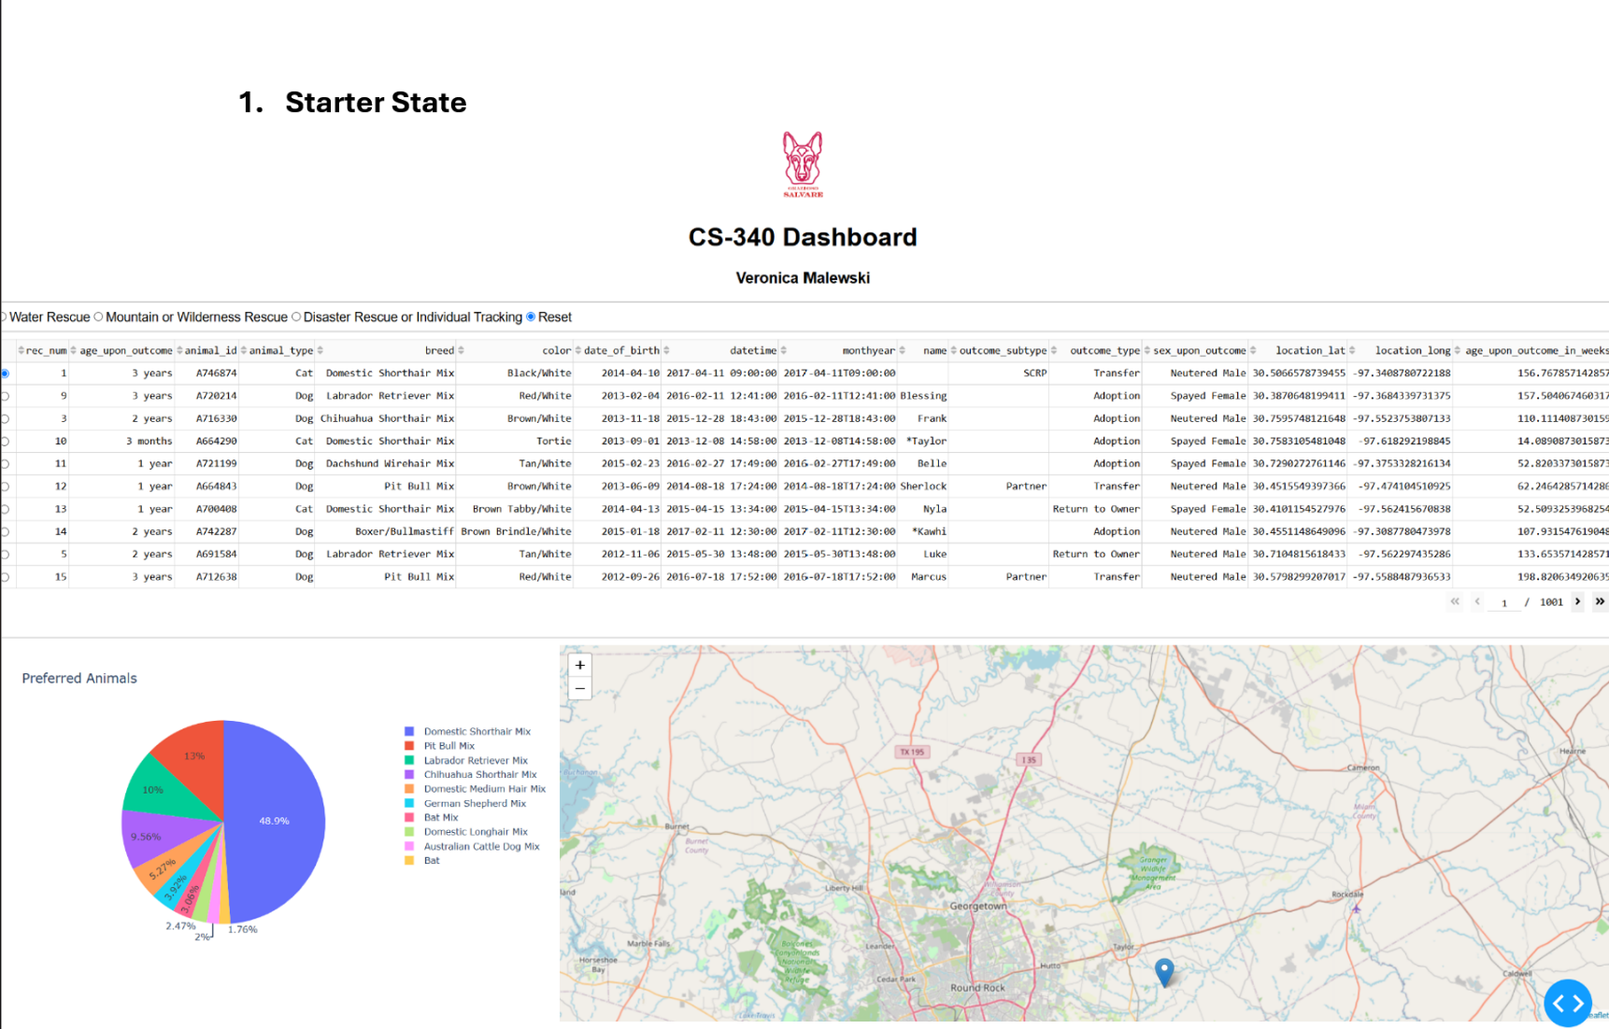

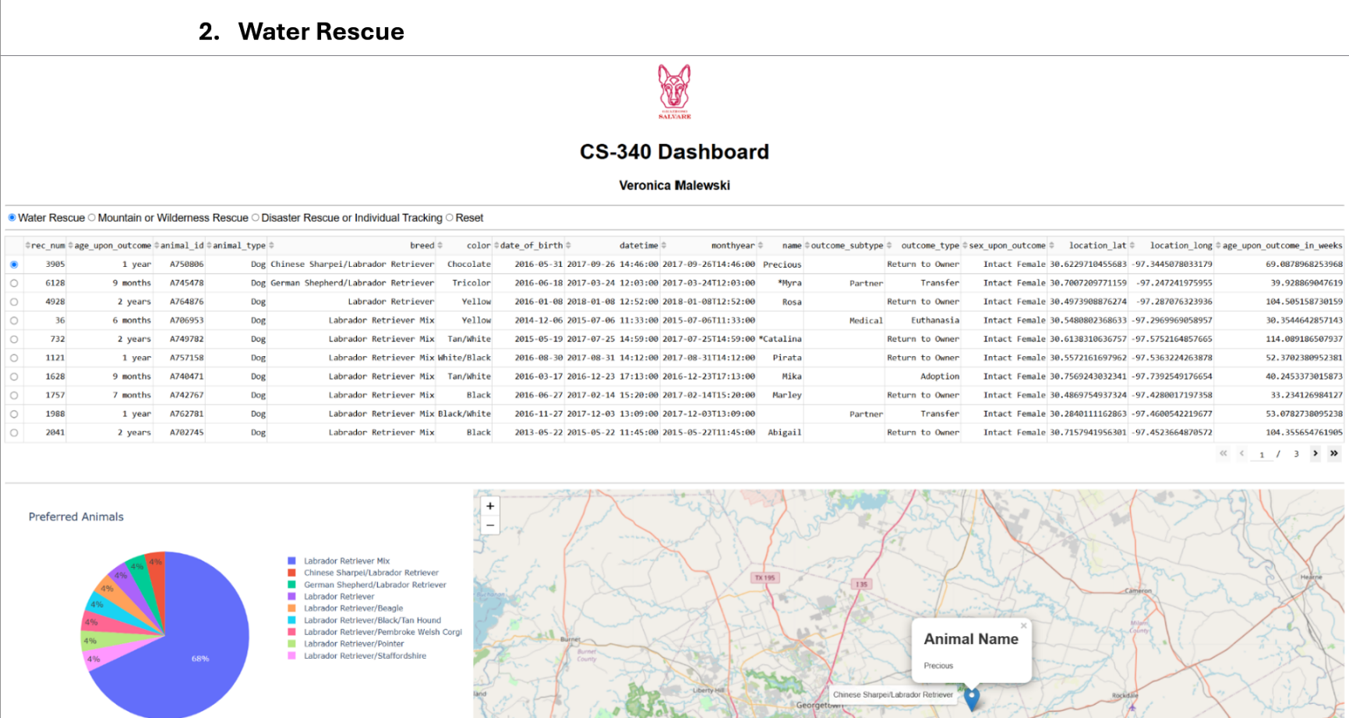

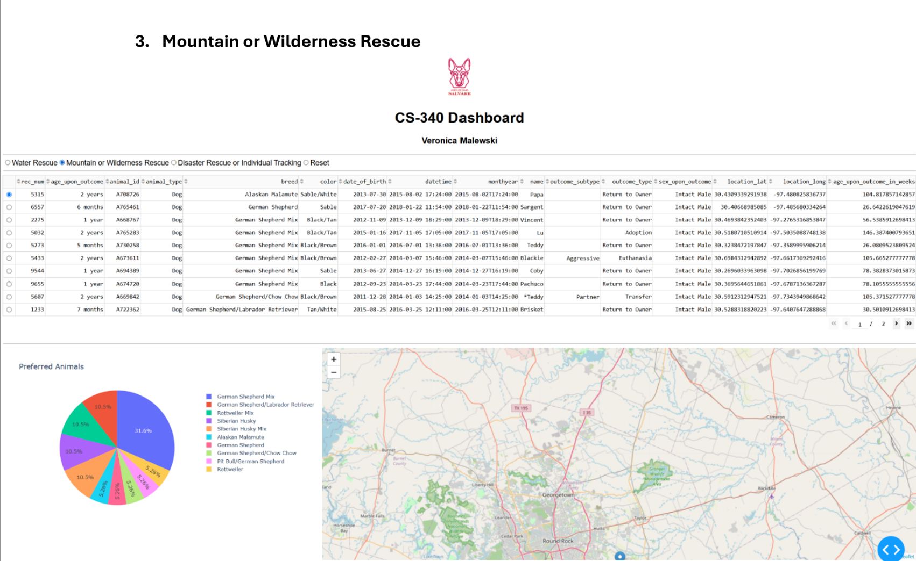

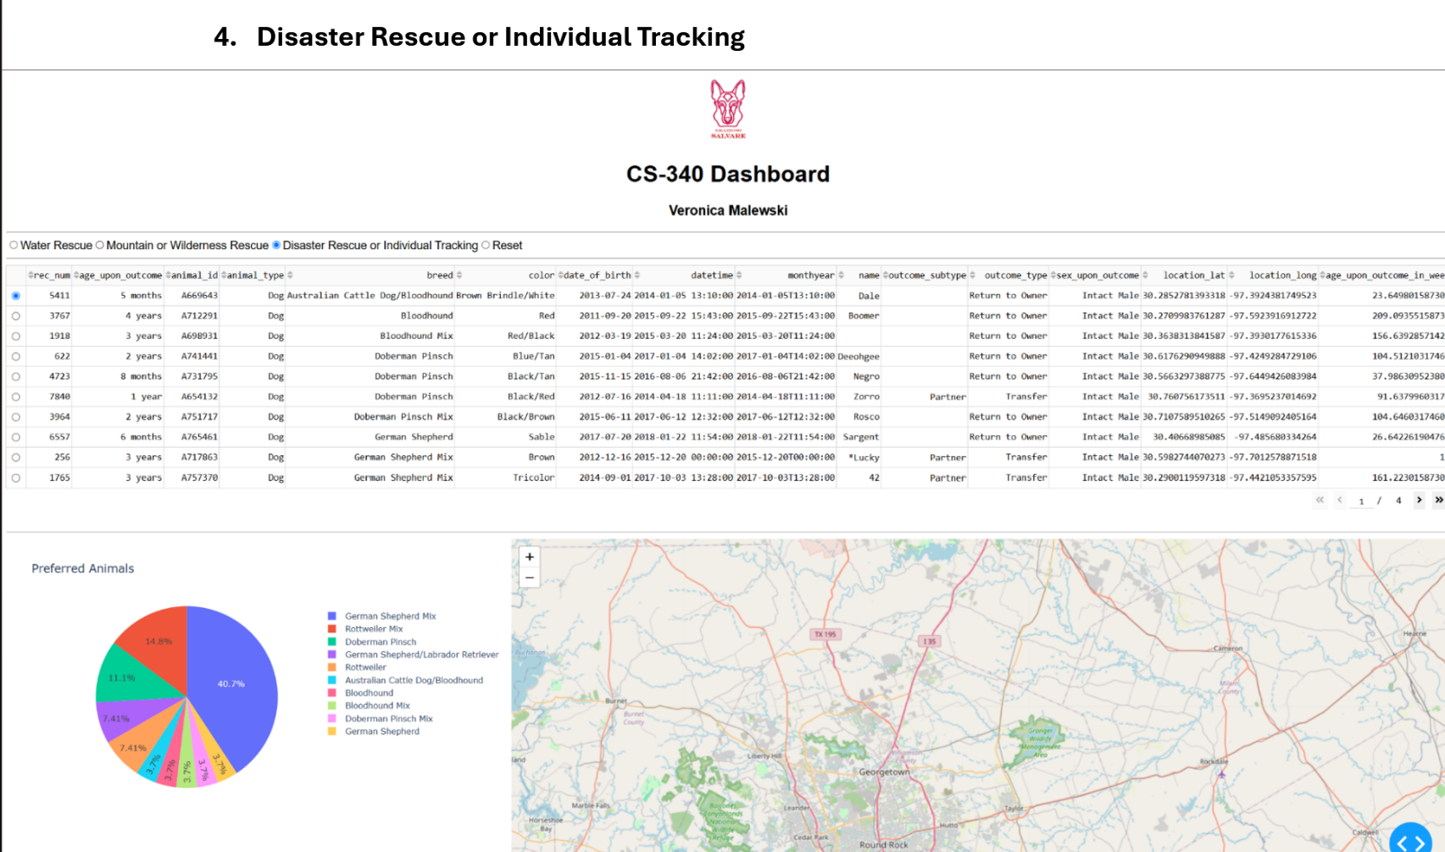

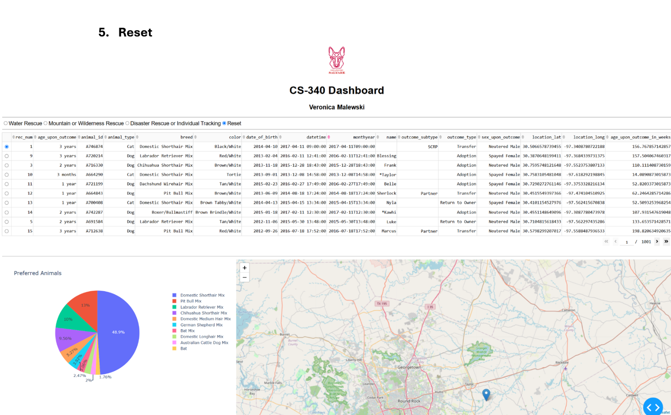

References
Austin Animal Center. (2020). Austin Animal Center Outcomes [Data set]. City of Austin, Texas Open Data Portal. https://doi.org/10.26000/025.000001
Microsoft. (n.d.). Architecture strategies for testing. Microsoft Learn. https://learn.microsoft.com/en-us/azure/well-architected/operational-excellence/testing
MongoDB, Inc. (n.d.). PyMongo driver documentation. MongoDB. https://www.mongodb.com/docs/languages/python/pymongo-driver/current/
Southern New Hampshire University. (n.d.-a). CS 340 Dashboard Specifications Document [Course document].
Southern New Hampshire University. (n.d.-b). CS 340 Project Two Guidelines and Rubric [Course document].
Southern New Hampshire University. (n.d.-c). Module Six Milestone Guidelines and Rubric [Course document].

